Dashboard
Customer_data,order_data,return_data.

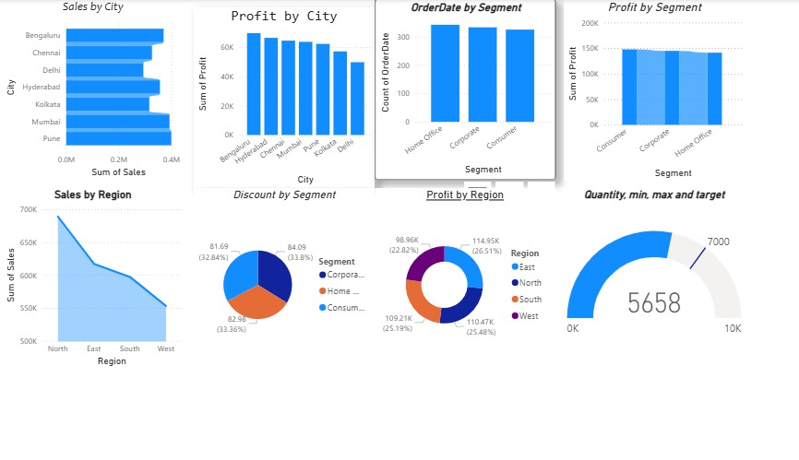

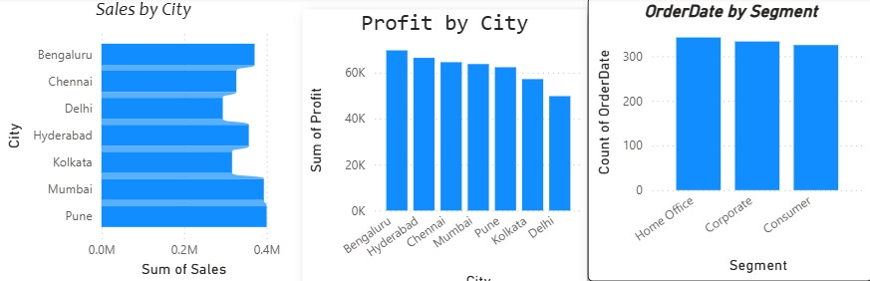
- Sales by city
Pune & mumbai show highest sales,while delhi record the lowest.most major cities moderate but consistent sales performance
- Profit by city
Banguluru leads in profit,followed closely of hyderbad and chennai.delhi shows the lowest profit
- Order date by segment
almost equal order volume ,home office eing slightly higher.this shows well-balanced customer base across segment
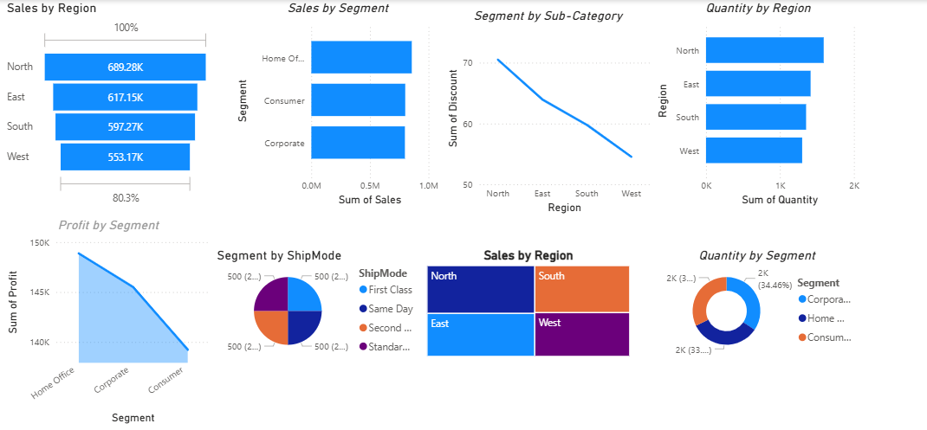

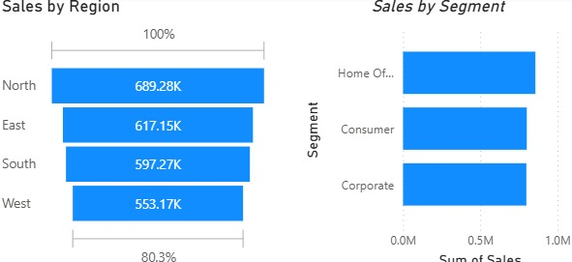

1. Sales by Region (Horizontal Bar Chart)

The chart displays total sales values for four regions: North, East, South, and West.

North has the highest sales, reaching around 689K.

East follows with about 617K, slightly lower than North.

South is close behind at around 597K

Insight
The difference between the highest (North) and lowest (West) sales is moderate, showing no extreme gap, but still highlighting variation in performance.

Insight
The difference between the highest (North) and lowest (West) sales is moderate, showing no extreme gap, but still highlighting variation in performance.

2. Sales by Segment (Vertical Bar Chart)

The second chart compares sales by segment: Home Office, Consumer, and Corporate.

Home Office has the highest bar, indicating the largest sales contribution among the three segments.

Consumer is moderately high.

Corporate is slightly lower than Consumer.

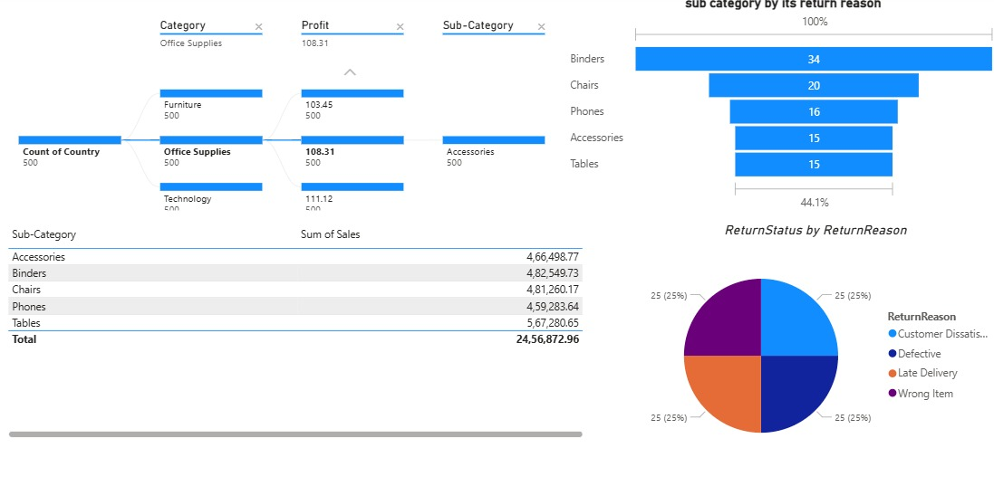

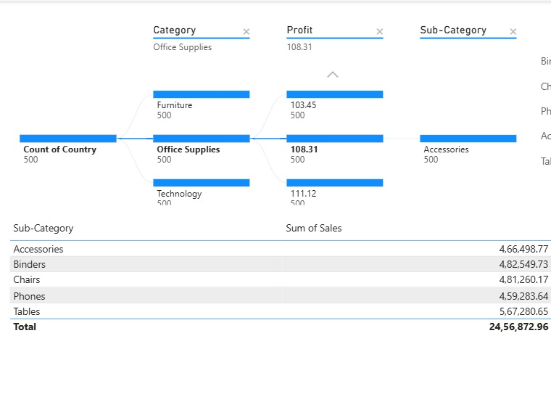
The main visuals include:

* Decomposition Tree (Category → Profit → Sub-Category)
* Tabular View of Sub-Category vs Sum of Sales
Observation:

* Technology shows the highest profit among categories.
* Office Supplies is moderately profitable.
* Furniture has comparatively lower profit.

This indicates Accessories under Office Supplies is a significant contributor in terms of count and profitability.
* Tables generate the highest sales.
* Phones have the lowest sales among listed sub-categories.
* Overall total sales amount is *24,56,872.96*.

Business Insights

* Focus on Technology category as it yields highest profit.
* Tables should be prioritized for promotions and inventory due to high sales contribution.
* Accessories show consistent performance and can be bundled strategically.
* Low-performing categories like Phones may need marketing optimization.

Recommendations

* Increase inventory for high-performing sub-categories like Tables.
* Analyze regional variations to further enhance profit margins.
* Continue monitoring profit trends across categories.

Conclusion
This dashboard effectively highlights category-wise profit and sub-category sales performance. It helps stakeholders make informed decisions about product focus, pricing strategies, and inventory planning.
- Sai sruthi



